Core Area business loans and grant programs
Downtown and Old East Village loan and grant programs
The following loans and grants are available to businesses located in the Downtown and Old East Village Community Improvement Plan areas (see Figure 1 below). Please email CIPincentives@london.ca for more details.
- Façade Improvement Loan - A loan from the City to improve building facades, including upgrades to windows, doors, brick repair, painting, lighting, and signage that is affixed to the façade. The loan will cover 50% of the cost of the improvements — up to a maximum of $50,000. This loan can be paid back at 0% interest over a 10-year period. In certain areas, a portion of the loan may be forgivable.
- Upgrade to Building Code Loan – A loan from the City for improvements to the interior of your building, including upgrades related to plumbing, electrical, HVAC, mechanical, roof, fire protection systems, and other Building Code related work. The loan will cover 50% of the cost of the improvements — up to a maximum of $200,000. This loan can be paid back at 0% interest over a 10-year period. In certain areas, a portion of the loan may be forgivable.
Core Area grant programs
Grants listed below are available to businesses located in the Core Area Community Improvement Plan area (see Figure 1 below). Please email CIPincentives@london.ca for more details.
- Core Area Safety Audit Grant - This program is focused on assisting property owners and tenants with making safety improvements to their building by assisting with a portion of the cost associated with exterior lighting, exterior security cameras, and storefront gates to close front entrance alcoves and recessed entryways when the ground floor business is closed or the building is vacant. The one-time grant will cover 50% of the cost of the improvements — up to a maximum of $10,000.
- Core Area Boulevard Café Grant - This program is intended to reduce the financial burden on business owners who operate sidewalk patios. This grant program eliminates the administrative and licence fees related to the operation of a patio on the public right-of-way. To be eligible for the program, the applicant must either apply for a Boulevard Café Permit or have an existing Permit with a Licence Agreement.
- Core Area Sign Grant - This program is designed to offset administrative and licence fees related to sign permits, including the encroachment of signs on a City street or road allowance. Eligible fees that will be granted through the program include applications fees associated with Sign Permits, Encroachment Agreements for signs, and Annual Encroachment Licence Fees for signs. To be eligible, the applicant must apply for a new Sign Permit or have an existing Encroachment Agreement for a sign.
Grants and loans for property owners
The following loans and grants are available to businesses located in the Downtown and Old East Village Community Improvement Plan areas (see Figure 1 below). Please email CIPincentives@london.ca for more details.
- Rehabilitation and Redevelopment Tax Grant - This program rebates a portion of the municipal tax increase that results from the rehabilitation of an existing building or construction of a new building. A percentage of this tax increment is rebated back to the property owner each year for ten years.
- Residential Development Charges Grant - This program is aimed at encouraging private sector investment in Downtown and Old East Village residential property development. A grant equal to a rebate of Development Charges (DCs) is provided for residential units constructed. DCs are required to be paid up-front at the time the building permit is issued. This program grants back a portion of the residential DCs paid by the applicant over a 10-year period until 100% of the residential DCs have been repaid to the applicant.

The following loans and grants are available City-wide. Please email CIPincentives@london.ca for more details.
- Affordable Housing Development Loan – This program provides a loan for each affordable rental unit created. A minimum of five affordable rental units must be created. The amount of the loan depends on the level of affordability being provided compared to Average Market Rent (AMR), the location of the project, and whether the developer pays property taxes. Please email CIPincentives@london.ca for more details.
- Additional Residential Unit Loan – This program provides a loan of up to $20,000 for the creation of an additional residential unit (ARU) within an existing residential building or on the same property (for example, above a detached garage or in a coach house). To be eligible for this loan, the main dwelling on the property must be owner-occupied and a valid Residential Rental Unit License (RRUL) must be maintained and renewed annually with the City. Please email CIPincentives@london.ca for more details.

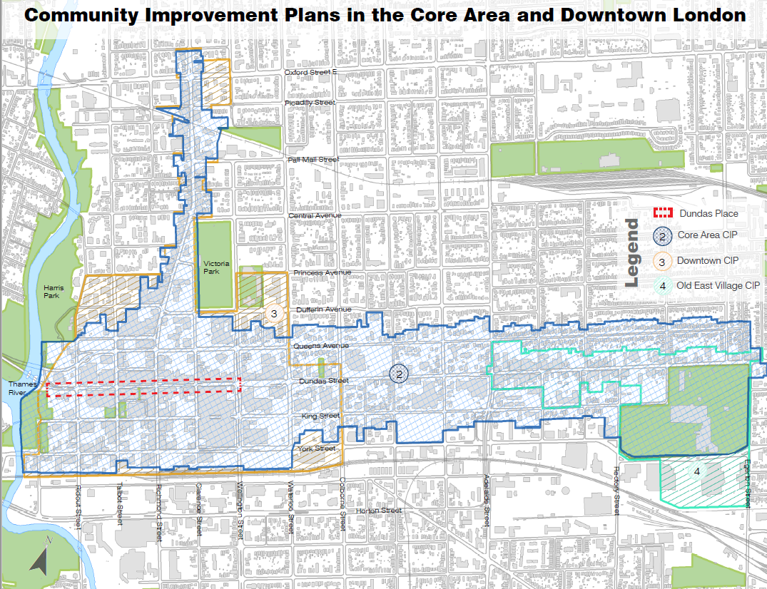
Figure 1: Core Area, OEV, and Downtown CIP areas

